July 2022 marks the 57th anniversary of Medicare, which was signed into law by President Lyndon B. Johnson on July 30, 1965. Medicare is the federal health insurance program created for people aged 65 and over, regardless of income, medical history, or health status. The Medicare program has grown dramatically over the past 57 years, from serving 19.1 million individuals in 1966 to 64.2 million in 2021. This corresponds with an even greater explosion in Medicare spending, which rose from $7.5 billion in 1970 to $925.8 billion in 2020. Experts have described the growth of U.S. health care spending as unsustainable. In 2020, Medicare spending comprised 12 percent of the federal budget and 20 percent of national health care spending. An increasing aging population will lead to to higher Medicare enrollment, with a forecasted covered population of over 93 million in 2060. The 2022 Medicare Trustees Report projects the Part A Hospital Insurance Fund will be insolvent by 2028.

SOCIAL MEDIA TOOLKIT
Promoting the 57th Anniversary of Medicare on July 30th

THEN | NOW
19.1 million beneficiaries enrolled in Medicare in its first year in 1966  (9.7% of U.S. population) | 64.2 million beneficiaries were enrolled in Medicare in 2021  (19.3% of U.S. population)
236% GROWTH
$7.5 billion in total Medicare spending in 1970  (3% of U.S. federal budget) | $925.8 billion in total Medicare sending in 2020  (12% of U.S. federal budget)
12,244% GROWTH
ACOs have been shown to reduce cost and improve quality. Since 2012, Medicare ACOs have saved $13.3 billion in health care dollars and have generated $4.7 billion in direct savings to Medicare. The 2022 Medicare Trustees Report notes the impact of cost savings generated by ACOs and calls for more investment into these payment models given the potential to further help with cost savings and prolong the Medicare Trust Fund. To celebrate the 57th #MedicareAnniversary and spread awareness of the importance of value-based care models, NAACOS is launching a month-long social media and communications campaign. Throughout the month of July, we are encouraging members to share their support for value-based care as a way to #ProtectMedicare. Below you will find sample hashtags, draft posts for social media, helpful graphics, and key messaging points. We also encourage you to draft your own commentaries and letters to the editor to spread this message to your local communities and networks. If you're unsure how to reach local news outlets, most have a tip line or email address. Don’t forget to include smaller, community newspapers, business journals, and websites.
Hashtags to use:
#MedicareAnniversary
#ProtectMedicare
#PaymentReform
#ValueForPatients
#ValueForMedicare
Sample Twitter posts:
Join us & @NAACOSnews in celebrating the 57th #MedicareAnniversary this month! ACOs & other alternative payment models have proven to improve patient care & reduce costs, giving the best opportunity to #ProtectMedicare for future generations
We’re joining @NAACOSnews to celebrate 57th #MedicareAnniversary. We must address Medicare’s looming insolvency if we want to see the program thrive for another 57 years and beyond. Meaningful #PaymentReform is urgently needed to #ProtectMedicare
Medicare needs better ways to reign in out-of-control costs and improve quality. ACOs can help. ACOs improve care for patients and generate billions in savings for Medicare. #ProtectMedicare by promoting #ValueforMedicare and #ValueforPatients. https://bit.ly/2020ACOresults
Patients cared for by ACOs receive coordinated, whole-person care. We need more of that in Medicare. Celebrate the 57th #MedicareAnniversary by promoting #ValueforPatients! https://www.naacos.com/about-acos
Medicare is projected to go insolvent by 2028, and value-based care models can help extend its life. We can #ProtectMedicare by promoting #PaymentReform that rewards high-quality, coordinated care for patients. https://bit.ly/2020ACOresults
ACOs are the only traditional Medicare program where providers are organized to coordinate care across the full healthcare continuum. In honor of the 57th #MedicareAnniversary, we should celebrate the programs that provide #ValueforPatients and #ValueforMedicare!
Value-based care rewards providers by keeping patients healthy, happy & out of the hospital. They do this by providing coordinated, holistic care that meets patients’ needs. We’re celebrating this #MedicareAnniversary by promoting #ValueforPatients!
Sample LinkedIn posts:
This month marks the 57th anniversary of Medicare. To celebrate the #MedicareAnniversary, we’re showing our support for #PaymentReform efforts that provide #ValueforPatients while controlling rising health care costs. ACOs have saved the Medicare program billions of dollars since 2012 while providing better care to patients. https://bit.ly/2020ACOresults
This July is the 57th #MedicareAnniversary. Signed into law on July 30, 1965, the Medicare program has grown to provide health insurance coverage to more than 64 million individuals. But rising health care costs and an increasingly aging population have created an unsustainable financing model. The most recent Medicare Trustees Report projected the Part A Trust Fund will be insolvent by 2028. Now more than ever, we need to promote #PaymentReform that provides #ValueforMedicare to ensure this important federal program is available for future generations.
ACOs are the only traditional Medicare program where providers are organized to coordinate care across the full healthcare continuum. Medicare ACOs deliver coordinated, comprehensive care to patients, while preserving all the rights and benefits afforded to them under traditional Medicare. In honor of the 57th #MedicareAnniversary, we should celebrate the programs that provide #ValueforPatients and #ValueforMedicare! https://www.naacos.com/about-acos
Value-based care rewards providers by keeping patients healthy, happy and out of the hospital, which is what we all want for ourselves and our loved ones. They do this by providing coordinated, holistic care that meets individual patients’ needs. In honor of the 57th #MedicareAnniversary this month, we’re promoting Medicare programs that provide #ValueforPatients! ACOs are the largest value-based payment model, and they have proven to provide better quality care for patients while controlling rising health care costs, providing an important opportunity to #ProtectMedicare from looming insolvency.
Sample graphics to share:
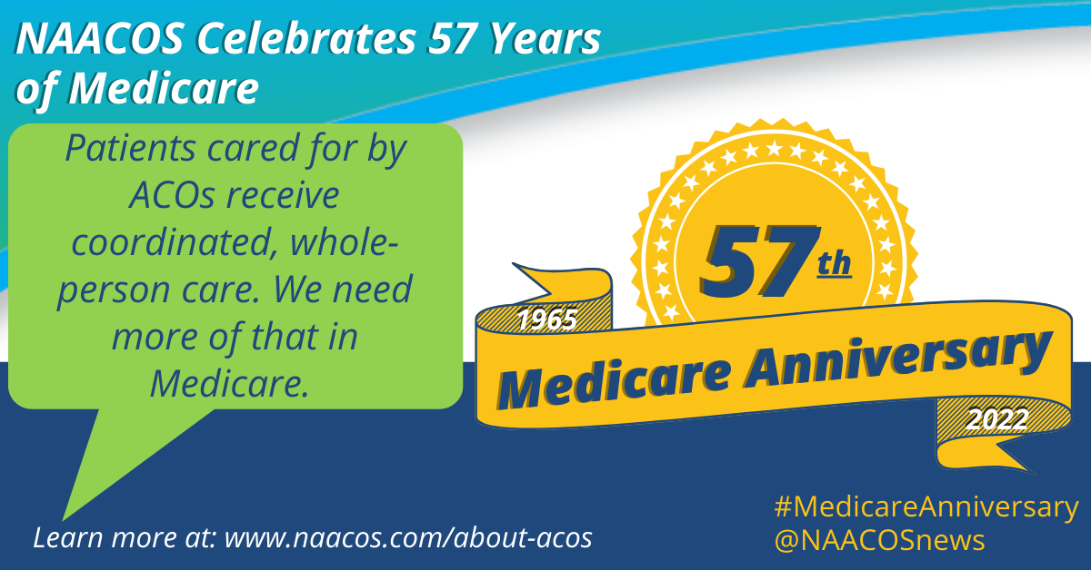
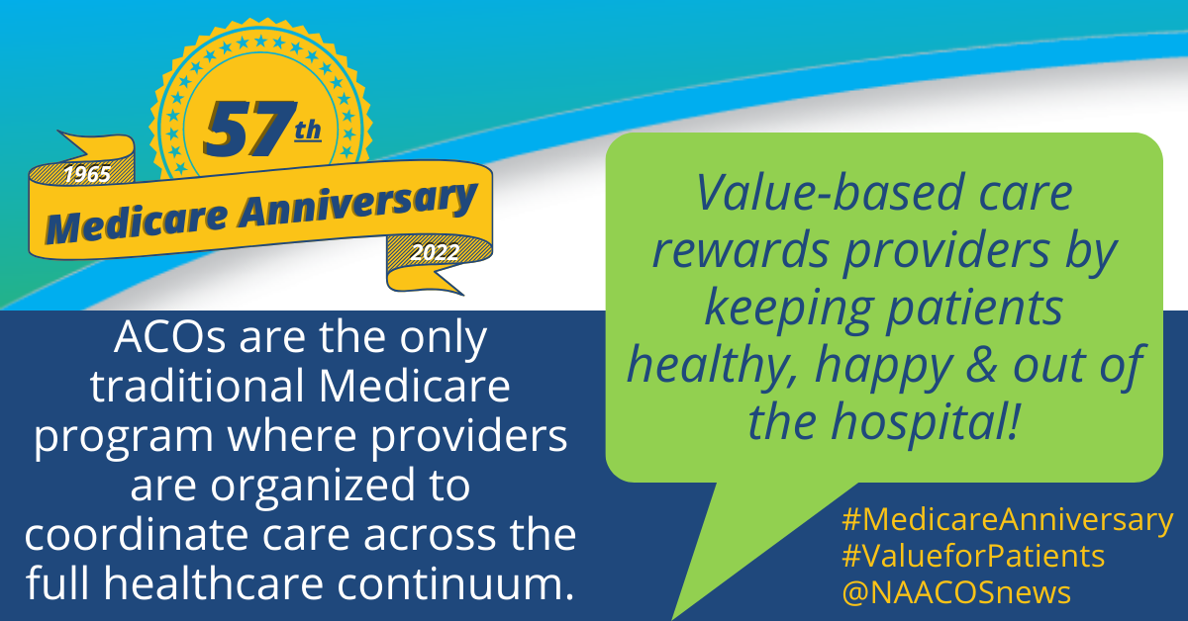
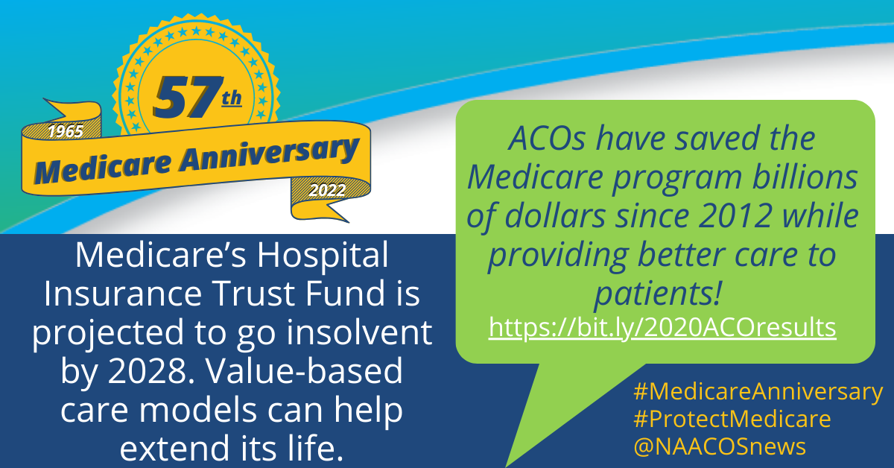

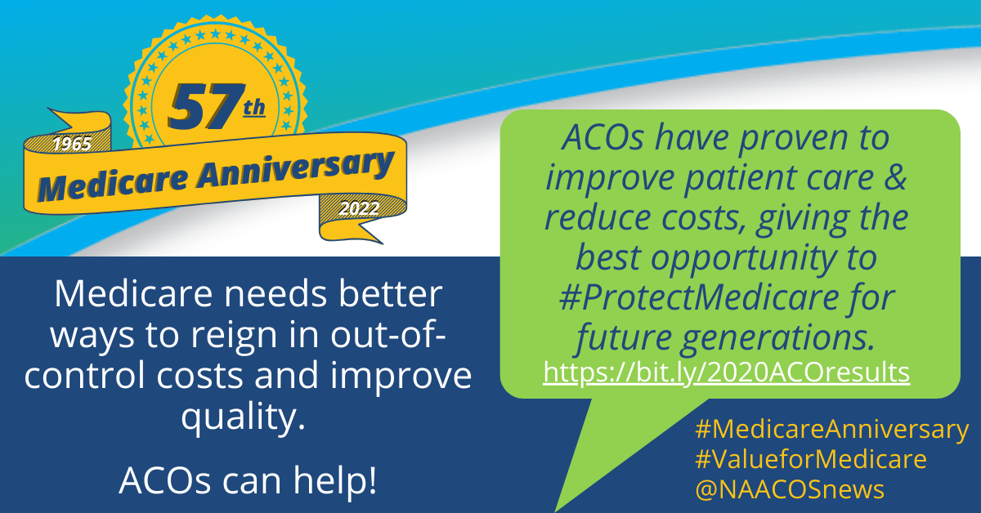

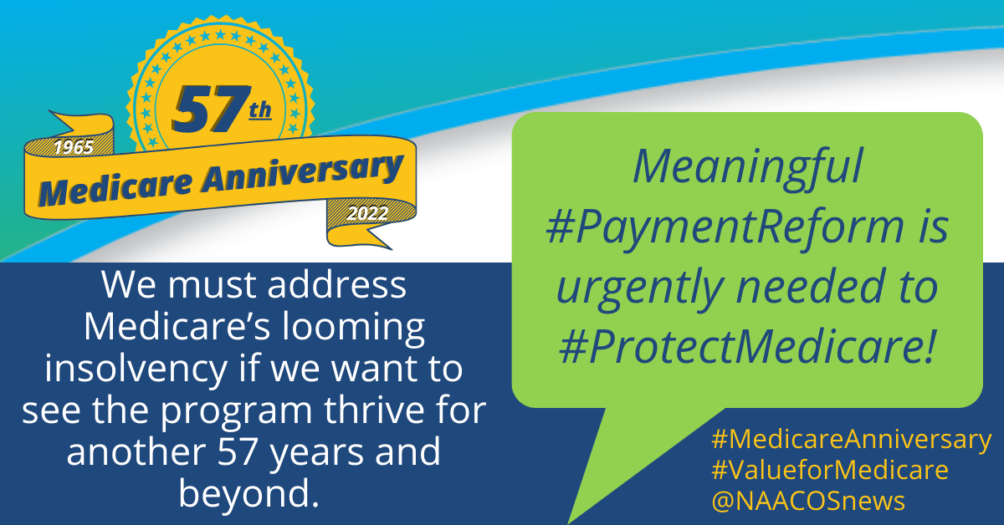

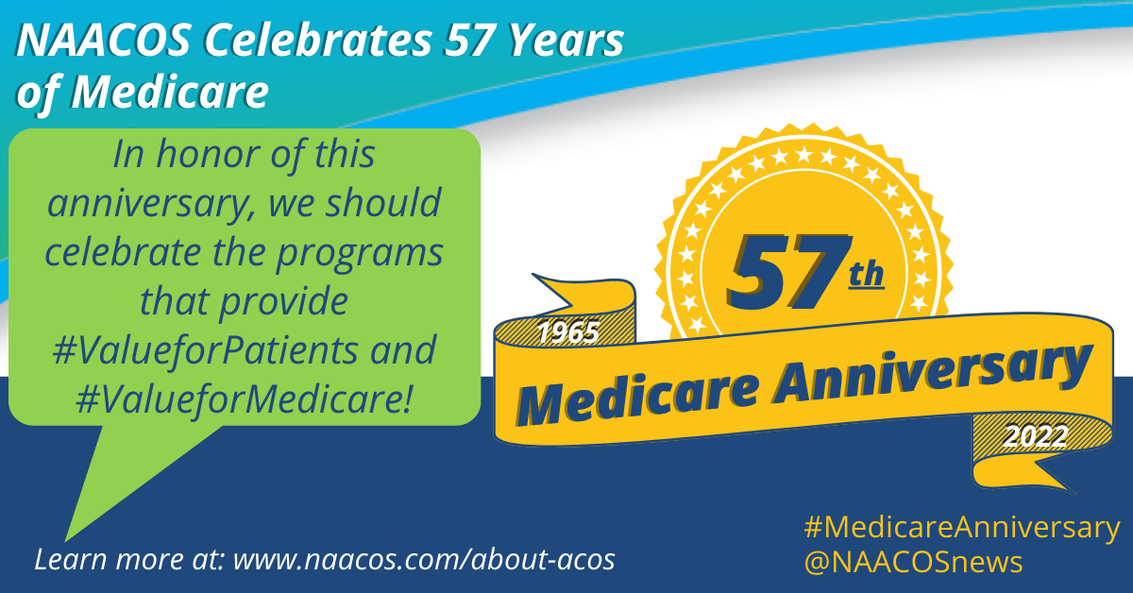

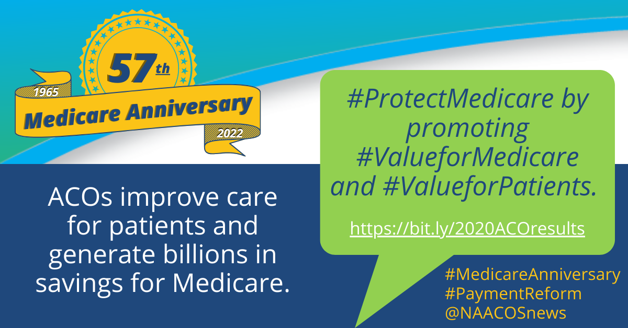
Key messages:
- Medicare’s Hospital Insurance Trust Fund is projected to go insolvent by 2028, and value-based care models can help extend its life.
- ACOs and other alternative payment models have proven to improve patient care and reduce costs.
- Medicare needs better ways to reign in out-of-control costs and improve quality. ACOs can help.
- ACOs are the largest value-based payment model in the country and an essential tool in moving toward better value.
- Value-based care rewards providers by keeping patients healthy, happy and out of the hospital.
- Patients cared for by ACOs receive coordinated, whole-person care. We need more of that in Medicare.
- ACOs are the only traditional Medicare program where the providers are organized to coordinate patients’ care across the whole healthcare continuum.

Additional links:
- The Facts About Medicare Spending (Kaiser Family Foundation): https://www.kff.org/interactive/medicare-spending/
- Fact Sheet: 2022 Social Security and Medicare Trustees Reports: https://home.treasury.gov/system/files/136/TR-2022-Fact-Sheet.pdf
- Highlights of the 2020 Medicare ACO Program Results: https://www.naacos.com/highlights-of-the-2020-medicare-aco-program-results
- ACO REACH Brings Next Era of Medicare Payment Models: https://www.ajmc.com/view/aco-reach-brings-next-era-of-medicare-payment-models
- Medicare Beneficiaries at a Glance: https://www.cms.gov/Research-Statistics-Data-and-Systems/Statistics-Trends-and-Reports/Beneficiary-Snapshot/Downloads/Bene_Snaphot.pdf
- 2022 Medicare Shared Savings Program (MSSP) Fast Facts: https://www.cms.gov/files/document/2022-shared-savings-program-fast-facts.pdf

Background:
In July 1965, under the leadership of President Lyndon B. Johnson, Congress created Medicare under Title XVIII of the Social Security Act to provide health insurance to people aged 65 and older, regardless of income or medical history. Johnson signed the Social Security Amendments of 1965 into law on July 30, 1965. Before Medicare was created, only approximately 60 percent of people over the age of 65 had health insurance, with coverage often unavailable or unaffordable to many others, as older adults paid more than three times as much for health insurance as younger people. Original Medicare (or traditional Medicare) was comprised of Part A (Hospital Insurance) and Part B (Medical Insurance). In 1972, the program was expanded to cover younger individuals with long-term disabilities.

Media inquiries:
Contact David Pittman, Senior Policy Advisor, 202-640-2689 or dpittman@naacos.com

About NAACOS:
The National Association of ACOs (NAACOS) represents more than 12 million beneficiary lives through hundreds of organizations participating in population health-focused payment and delivery models in Medicare, Medicaid, and commercial insurance. Models include the Medicare Shared Savings Program (MSSP), Global and Professional Direct Contracting Model, and alternative payment models supported by a myriad of commercial health plans and Medicare Advantage. NAACOS is a member-led and member-owned nonprofit organization that works to improve quality of care, outcomes, and healthcare cost efficiency.

